Instructions for Ricoh Aficio MP C4503

Step 1: Go to the printer and click on the screen to turn it on.
Step 2: There are two different types of screens; see the pictures below and continue.

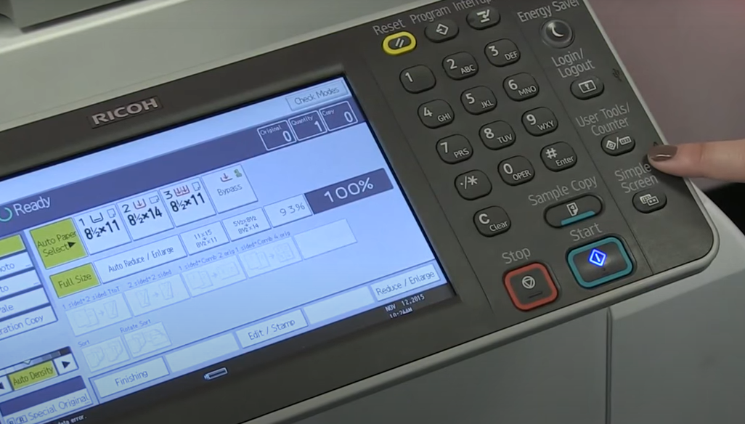

Step 3: Click the user tools/counter button as pictured below.
Or if you have a touch screen, swipe to the right, then click user tools. 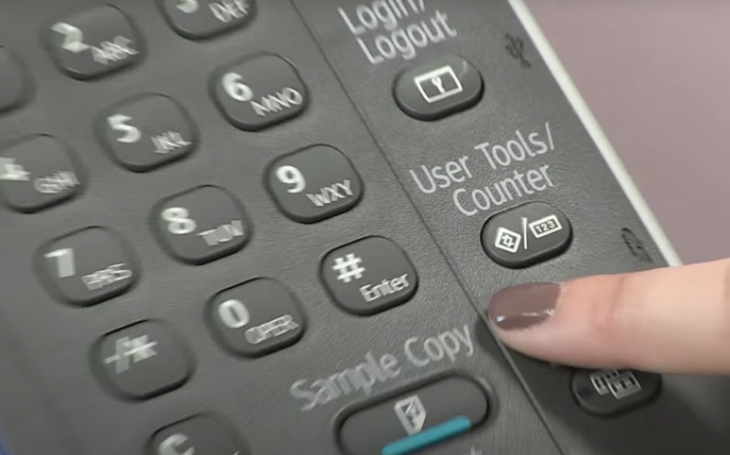

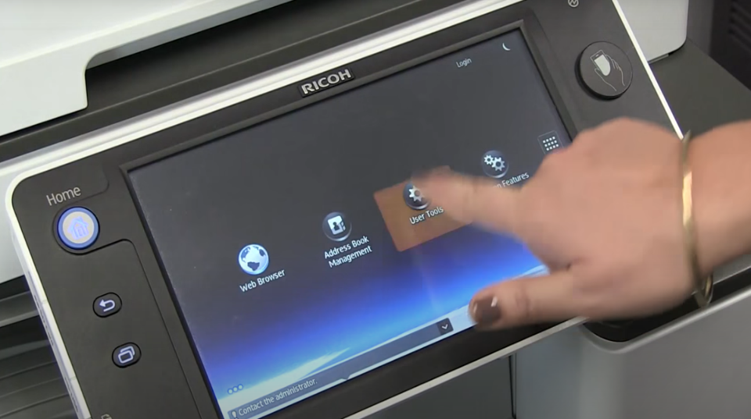
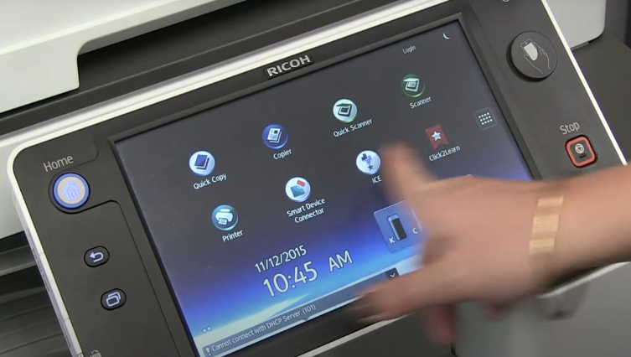

Step 3 cont.: swipe to the right and click user tools as pictured to the left.

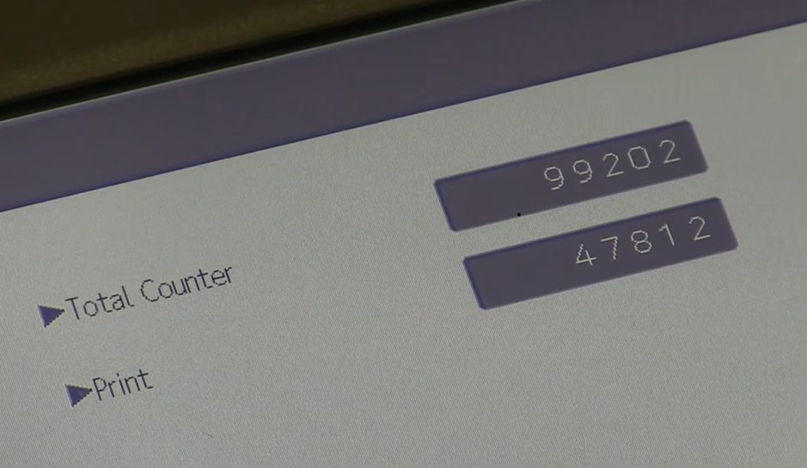
Step 4: Record the total counter as shown in the picture above.

Step 4 pt 2: if you do not have a touch screen, see below. Click the start button to print off the counter page.
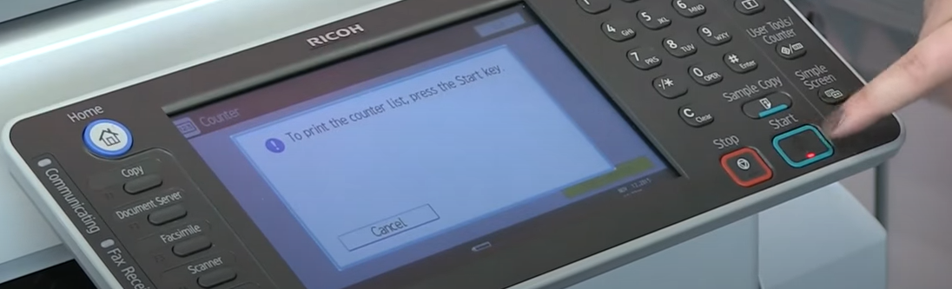

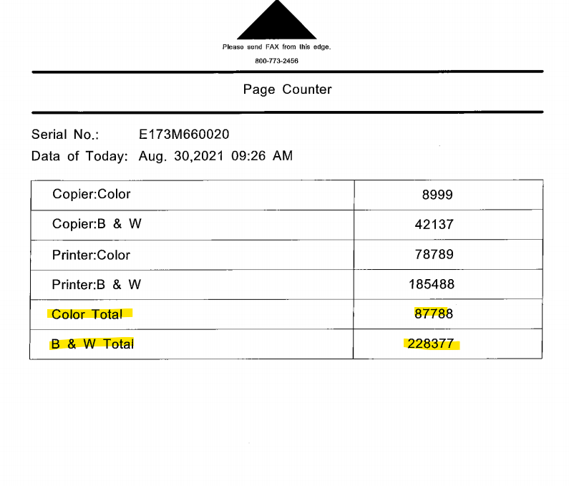
The highlighted number on the counter pictured above is the meter reads ImageNet Consulting uses to keep track of printing on the machine.
The numbers highlighted on the bottom are what can be entered in the link provided via email or provided over the phone to a meters specialist.
Please send meters and or scan the counter page to meters@imagenet.com .
If you need further assistance or have any questions call 1-800-937-2647 and press 9 for meters or 0 for the operator to direct you.

