Instructions for HP Laser Jet Pro P2035DN Printer

Step 1: Go to the printer and click the #6 button twice to print the configuration page as shown below.
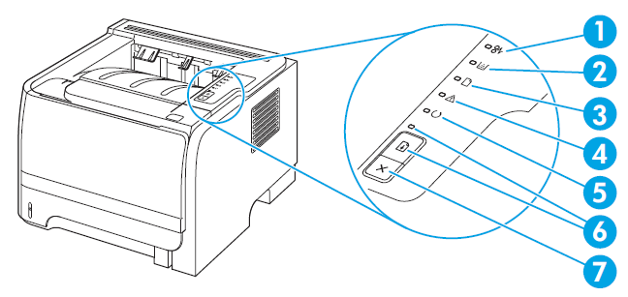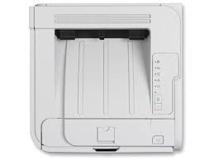

Step 2: Submit the numbers or scan the sheet.
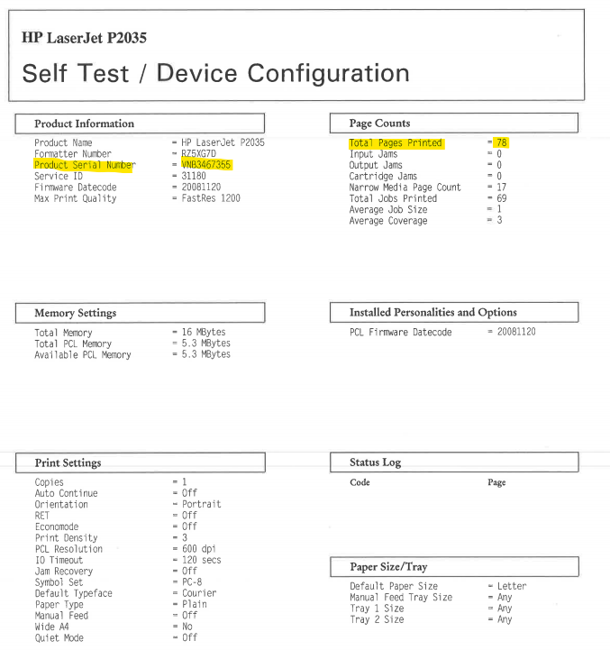

The highlighted number on the usage page pictured above is the meter read ImageNet Consulting uses to keep track of printing on the machine.
The number highlighted is what can be entered in the link provided via email or provided over the phone to a meters specialist.
Please send meters and or scan the usage page to meters@imagenet.com .
If you need further assistance or have any questions call 1-800-937-2647 and press 9 for meters or 0 for the operator to direct you.

