Instructions for HP Laser Jet PRO M404DN/ HP Laser Jet PRO M402DN

Step 1: Go to the printer and click the “ok” button as pictured below.

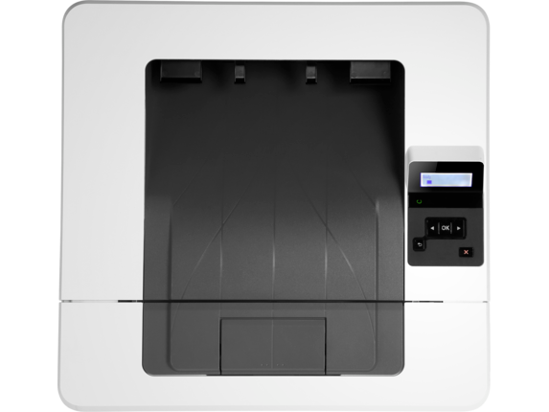

Step 2: Click the right arrow button over to reports. You should see “set up menu reports”.
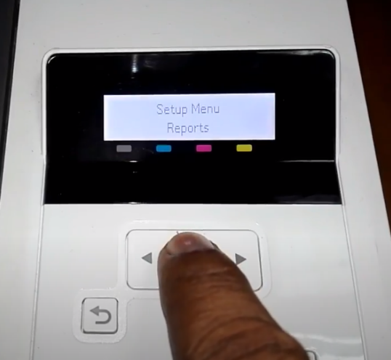
Step 3: Click the right arrow button again over to Usage Page. You should see “Reports usage page”. Then click “ok”.

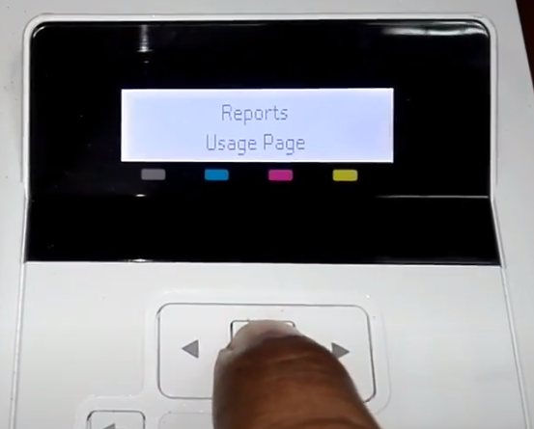
(The usage page is pictured below)

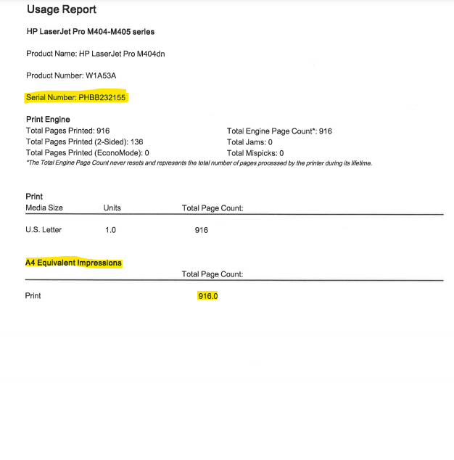
Step 4: Submit numbers or scan in Usage page. Always use the numbers under “equivalent impressions.”
The highlighted number on the usage page pictured above is the meter read ImageNet Consulting uses to keep track of printing on the machine.
The number highlighted is what can be entered in the link provided via email or provided over the phone to a meters specialist.
Please send meters and or scan the usage page to meters@imagenet.com .
If you need further assistance or have any questions call 1-800-937-2647 and press 9 for meters or 0 for the operator to direct you.

