Instructions for HP Laser Jet M521DN

Step 1: Go to the printer and click on the screen to turn it on.
Step 2: tap the wrench and gear icon as pictured below. This is the set-up menu.

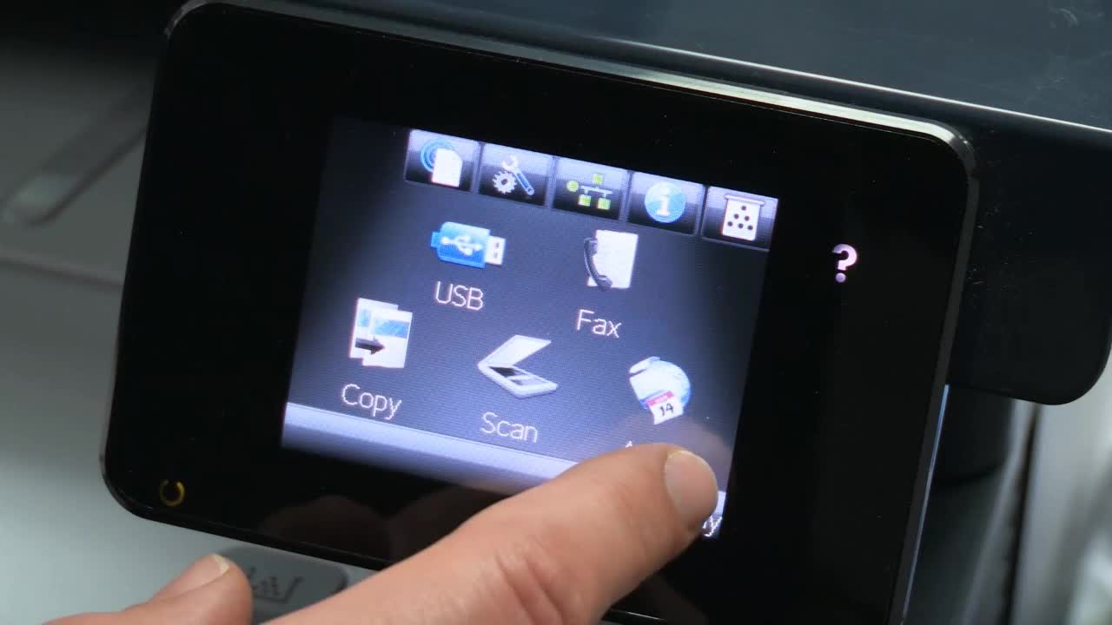

Step 3: Click the reports button as pictured below.
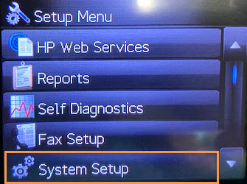

Step 4: Scroll to the bottom of the page and click “usage page”. It will automatically print off the usage page.
(The usage page is pictured below)
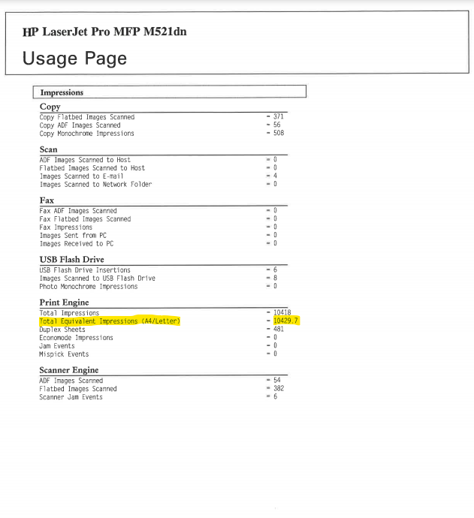
The highlighted number on the usage page pictured above are the meter reads ImageNet Consulting uses to keep track of printing on the machine.
The number highlighted is what can be entered in the link provided via email or provided over the phone to a meters specialist.
Please send meters and or scan the usage page to meters@imagenet.com .
If you need further assistance or have any questions call 1-800-937-2647 and press 9 for meters or 0 for the operator to direct you.

