Instructions for HP CLJ Pro M477fdn

Step 1: Go to the printer and swipe to the right, then click “setup.
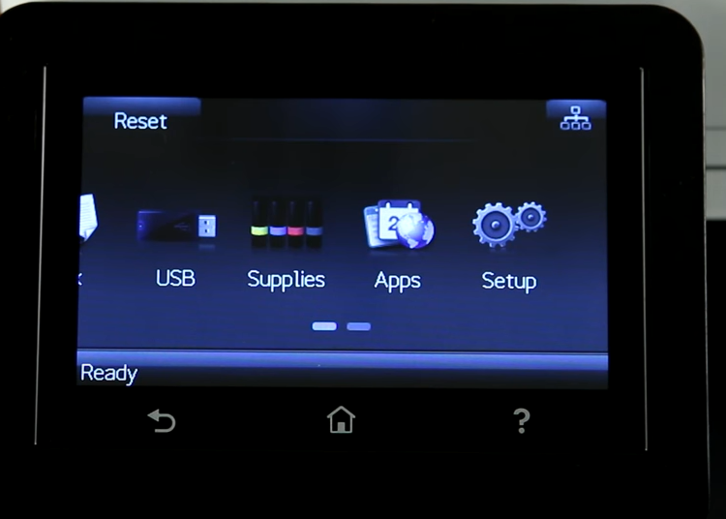
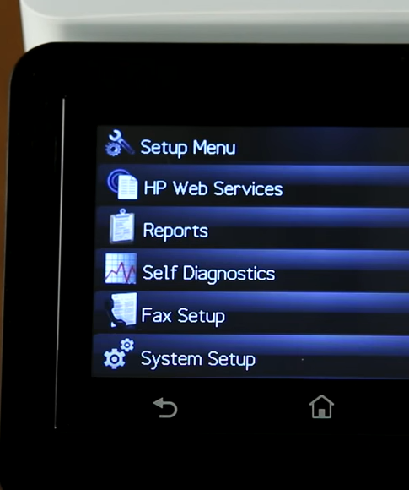
Step 2: Swipe to the right once and click “reports.”

Step 3: You should see “usage report/page” Click that and print off that page.
(There is a usage page example below) The highlighted number on the usage page pictured below are the meter reads ImageNet Consulting uses to keep track of printing on the machine.
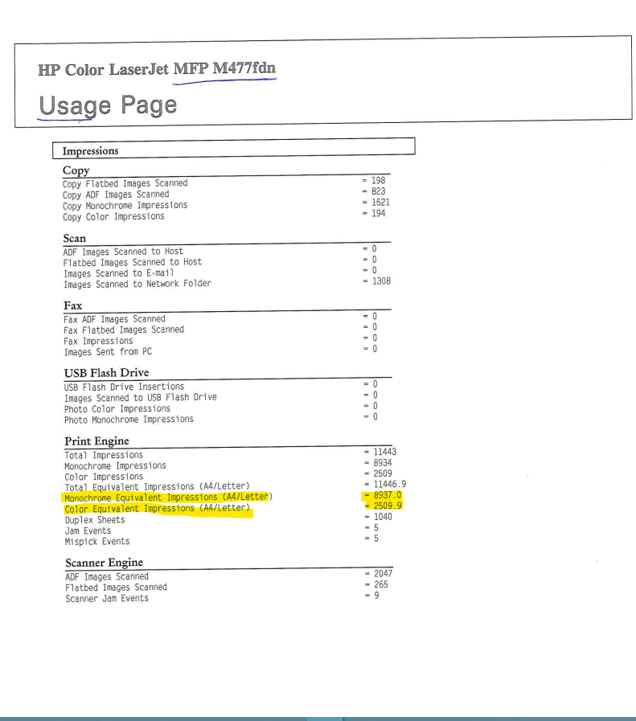
The number highlighted is what can be entered in the link provided via email or provided over the phone to a meters specialist.
Please send meters and/or scan the usage page to meters@imagenet.com .
If you need further assistance or have any questions call 1-800-937-2647 and press 9 for meters or 0 for the operator to direct you.

