Instructions for Canon ImageRunner
Step 1: Go to the printer and click on the “Counter” button on the control panel. (see below)
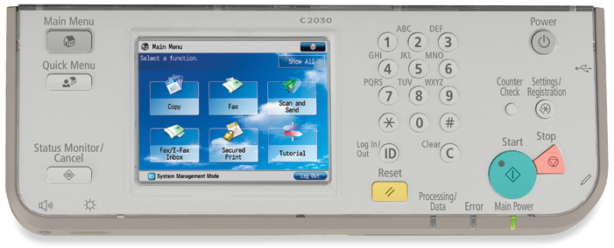
Step (2): If you do not see a counter button, press the small button labeled “123” either on the front or side of the machine. (see below).
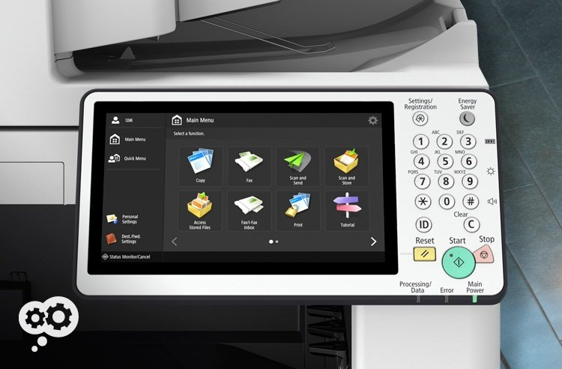
Step 3: You should see a screen pop up such as the one below. This is the counter page. If it is a black and white (BW) ONLY machine use 101 or 102. (102 if machine lists both).
If your machine is BW AND color: use 109 or 108 for the BW total and 124,106, or 105 for the color total.
Note: If the BW AND color machine only lists 101/102 and the 109/108 you will need to subtract the BW from the 101/102 (total) to find the color meter.

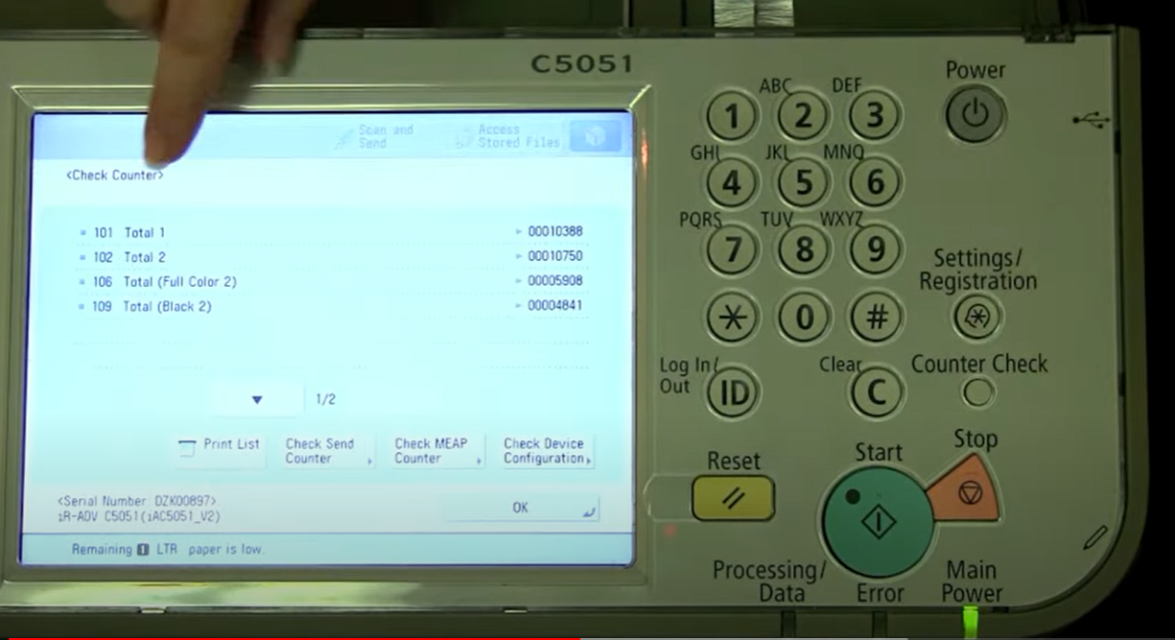
If you wish to print off the counter page to scan or keep for records, click the “print list” button the red arrow is indicating above.
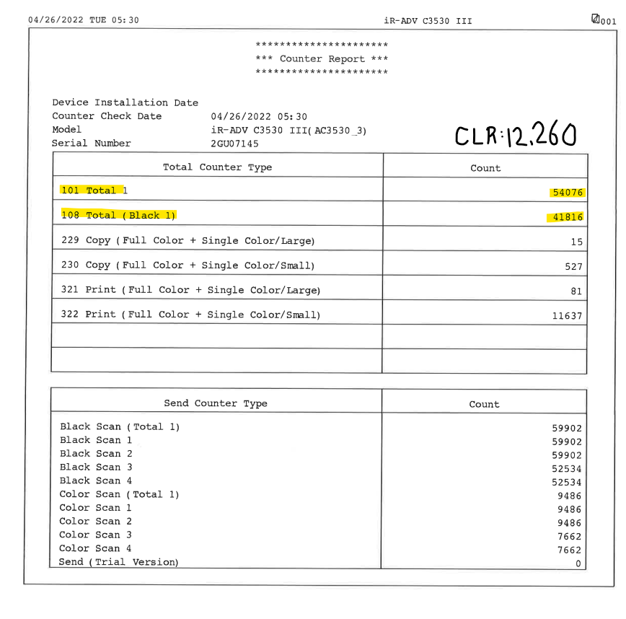
The above is an example of what a counter page looks like.
The highlighted numbers on the counter page pictured above are the meter reads ImageNet Consulting uses to keep track of printing on the machine.
The numbers highlighted are what can be entered in the link provided via email or provided over the phone to a meters specialist.
Please send meters and or scan the usage page to meters@imagenet.com .
If you need further assistance or have any questions call 1-800-937-2647 and press 9 for meters or 0 for the operator to direct you.

